Elements for Session 1: Sustainable Development

Table of contents
Introduction 2
1. Agenda 2030: What is different on environment? 3
1.1. A different process lead to different results: core principles of the 2030 Agenda. 3
1.2. A core element: the integrated approach. 3
1.3. Environmental sustainability is embedded across the SDGs. 5
2. Delivering on the environmental dimension of the 2030 Agenda for Sustainable Development in LAC. 7
2.1. Multiple national approaches to Sustainable Development. 8
2.2. Environmental sustainability and economic growth. 9
2.3. Moving to more sustainable consumption and production patterns: a cultural shift. 10
2.4. Ecosystem based resilience to decrease poverty and social inequalities. 11
3. Challenges: fast looking forward 13
3.1. Readiness phase will allow robust implementation: advances in LAC. 13
3.2. The role of Environment Ministries. 15
3.3. Regional cooperation for environmental sustainability. 17
Conclusions 18
References 20

Introduction

- The recent financial, food and fuel crises pose fundamental challenges for global development. Central issues such as growing inequalities, rising unemployment, climate-related impacts, migration and natural resource degradation are putting pressure on global leaders and policy makers to bring sustainable development in the core of domestic priorities.
- The Latin American and Caribbean (LAC) region is not indifferent to these global trends. Decelerating growth is expected to put at risk the recent accomplishments of the region in terms of poverty alleviation and social protection improvements. Considering the high level of inequality in LAC, this means millions of people falling again into the poverty trap. Ecosystem services, biodiversity and productive land in LAC continue to be lost and degraded due to, among others, the persistence of economies based on natural resources extraction, the unplanned urban growth and the expansion of the agricultural frontier.
- The reversion of the poverty reduction efforts, combined with an increasing inequality and environmental degradation, contributes to a high vulnerability to climate-related hazards with consequences that can compromise the gains already achieved and the viability of current and future generations’ development.
- This is the context in which the global agreement on Transforming our World: the 2030 Agenda for Sustainable Development (UNGA, 2015) was negotiated and adopted in September 2015. It has been the result of an intense participatory process by governments, civil society, the private sector and other development agents and therefore it has a high degree of commitment from all stakeholders to stablish a global partnership that promotes sustained and inclusive economic growth, social development and environmental protection.
- The wide recognition of the role of environmental sustainability in a prosperous future for all, challenges humanity to find different ways of ensuring well-being without resulting in scarcity, environmental degradation and the destruction of livelihoods. Collective action, coordination at all levels, and policies that take into account this interrelatedness will be critical to foster a transition to sustainable development. For instance, the Paris Agreement adopted at the UNFCCC COP21 provides a pathway forward to limit temperature rise and a mechanism to increase the level of ambition which implies a transformational change: the decarbonisation of the economies.
- The global development community is already assessing required strategies, means and resources to achieve this ambitious agenda, as 2016 is the year of starting the implementation of the Sustainable Development Goals (SDGs). In order to inform the regional Forum of Ministers, this paper aims at providing key elements on 1) what are the main implications of the 2030 Agenda design in terms of environmental sustainability; 2) how a better integration of environmental sustainability in social and economic realms can enforce the application of an integrated approach to sustainable development; and 3) which role can the environmental sector play in LAC in the implementation phase and the readiness steps already being taken at regional and national level.

Agenda 2030: A new approach to include the environmental dimension.

A different process lead to different results: core principles of the 2030 Agenda.
- People, Planet, Peace, Prosperity and Partnerships (i.e. the 5 P’s) are the central issues of the 2030 Agenda for Sustainable Development around which the opportunities to achieve a life of dignity for all, including future generations, in harmony with nature are addressed. The recognition of the need to achieve greater and inclusive prosperity, within the Earth’s life support system, puts environmental issues in a central place as never before.
- The most participatory process the World has embarked on so far led to a universal, aspirational and transformative agenda. In terms of environment, the principle of Universality has allowed for the integration of actions to protect and restore global environmental public goods in the new agenda. At the same time, whereas it is applied to all countries, it also considers the principle of Common But Differentiated Responsibilities that has remarkable implications in issues as central as climate change, oceans protection and equal access to the benefits of natural resources, among others. It also differentiates responsibilities and targets for different development contexts, developed nations, SIDS, LDCs.
- By recognizing the complexity of the transition towards sustainable development, it considers a greater number of matters through an integral and indivisible approach, and reflects them in its 17 Sustainable Development Goals (SDG) and 169 targets. In particular, the environmental elements and their interconnections with poverty eradication, social protection and other central development issues, offer a significant opportunity to promote a more comprehensive approach to sustainable development (UNEP, 2015a). This will result in strengthened global efforts to achieve environmental sustainability while allowing setting nationally-relevant targets adapted to the different national realities and priorities.

A core element: the integrated approach.

- It is worth mentioning the qualitative progress made, compared to the Millennium Declaration (UN, 2000) and which resulted from “The Future We Want” (UN, 2012), in reflecting an integrated approach to achieve sustainable development. The 2030 Agenda includes specific mechanisms to assure such comprehensiveness through the explicit recognition of the interconnectedness between social progress, economic growth and environmental sustainability. In other words, it is not possible to selectively make progress in some of the topics, but on the contrary, it is necessary to recognize the multi-causality of development challenges and the need to simultaneously achieve irreversible gains in all realms.
- The integrated approach requires various streams of work that are related to the 2030 Agenda’s means of implementation:

Policy coherence across various areas:
- The diversity of types of actions established in the SDGs, along with the inclusion of the environmental dimension in all of them, makes evident the importance of coordination and coherence in the actions at all levels, i.e. policy development and implementation at horizontal (multisectoral) and vertical (at a global, regional, national and local scale) (UNDG, 2015). This requires an institutional evolution that breaks the silos of centralized sector-based policy planning processes. It also forces to use systems thinking and new tools such as integrated scenario modelling when undertaking planning and policy-making (ESCAP, 2016).

Integration of international agendas and processes:
- The 2030 Agenda is consistent with existing obligations and commitments of States under international law, interlinking the diverse global agendas. It therefore includes specific reference to the Multilateral Environmental Agreements, and their targets are part of the SDGs. This facilitates a comprehensive approach to their implementation, monitoring and reporting. For example, SDGs related to land and biodiversity build on the UN Convention to Combat Desertification (UNCCD) initiative and on the biodiversity targets that were negotiated in 2010 under the Convention on Biological Diversity (CBD). Following the same rationale, commitments made under the UNFCCC, such as the INDCs (Intended, Nationally Determined Contributions) and the elaboration of comprehensive National Adaptation Plans (NAPs), should directly contribute to the implementation of the 2030 Agenda and the SDGs.

Coherence between different sources of finance:
- In the global economy all countries play a role in driving global growth and development. Particularly, emerging economies are playing an increasingly important role in international trade, finance and investment. A renewed compromise to increase official development assistance and climate change financing is complemented by targets related to the mobilization and coherent investment of domestic public resources, private business finance, international trade and debt (GA, “Addis Ababa Action Agenda”2015). This issue will be expanded later on in this paper.

Multi-stakeholder approaches and ownership:
- Collaborative work will be essential to achieve the SDGs. Even if SDG 17 specifically calls for strengthened global partnerships; this is not a stand-alone goal, but a catalyst at the core of all the goals. Engaging global, national, sub-national and local stakeholders in mechanisms that ensure a continued dialogue and coordination is critical in successful implementation. Challenges related to unsustainability in the LAC region, for example, will require private-public partnerships and investments involving sectors whose advocates may not currently perceive the value of environmental conservation with respect to the wider socioeconomic development agenda.

Environmental sustainability is embedded across the SDGs.
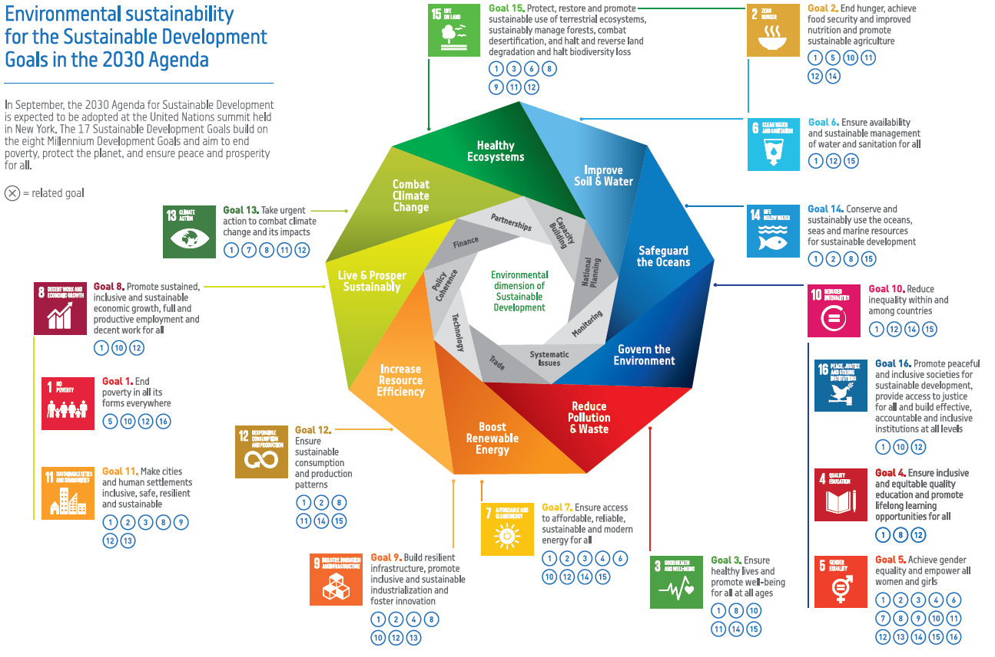
- The balanced integration of sustainable economic growth, social protection and justice, and environmental stewardship is reflected in the SDGs. In terms of environment, there is a significant progress in the number of targets that explicitly addressed it compared to the Millennium Development Goals (MDGs).
- The environmental dimension is virtually present in all SDG as over 86 targets specifically refer to environmental sustainability in linkage with: poverty, hunger, health, education, gender, water and sanitation, energy, economic growth, human settlements, sustainable consumption and production, climate change, oceans, and terrestrial ecosystems.
- The greater interrelation between environmental sustainability and the different objectives and goals is based in reducing environmental damage but also in the role of natural resources and ecosystem services in human wellbeing, economic opportunities and social and ecological resilience.

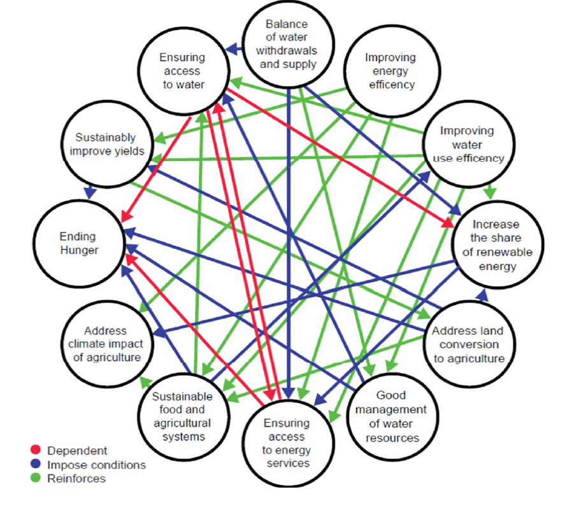
- One example is the clear inclusion of the land-energy-water-biodiversity nexus that came up as a priority in the outcome document of Rio+20. The SDGs recognize the linkages between water, energy and agricultural sectors since policies affecting one of these resources often include negative externalities for the others. Following this approach, for example, the water-related targets have broadened their scope from an emphasis on safe drinking water to its economic and ecological dimensions. This as a way to maximize the economic and social payoffs of managing water, land and related resources without compromising ecosystems (e.g. SDG targets as diverse as water use efficiency, decrease in water pollution, sustainable management of fisheries, wetlands, oceans and coastal ecosystems).
The food-energy-water nexus: interlinkages among SDG targets. Source: Weitz et. al. 2004.
- The proposed goals and targets are as a whole an integrated system or network of links among them. For example, disaster risk reduction is a cross-cutting issue embedded in targets of various SDGs that link each other referring to diverse ways to increase resilience (e.g. targets related to food security, infrastructure resilience, social protection, cities, etc.). For instance, on the other hand, achieving Sustainable Consumption and Production (SCP) patterns is a stand-alone goal (SDG 12) but has related targets in other goals that ensure greater synergies between them (UNEP, 2015e). As shown in the next figure, SDG 12 is critical in providing connections among other goals and makes the SDGs more tightly linked as a network through the connections that it creates (UNDESA, 2015).
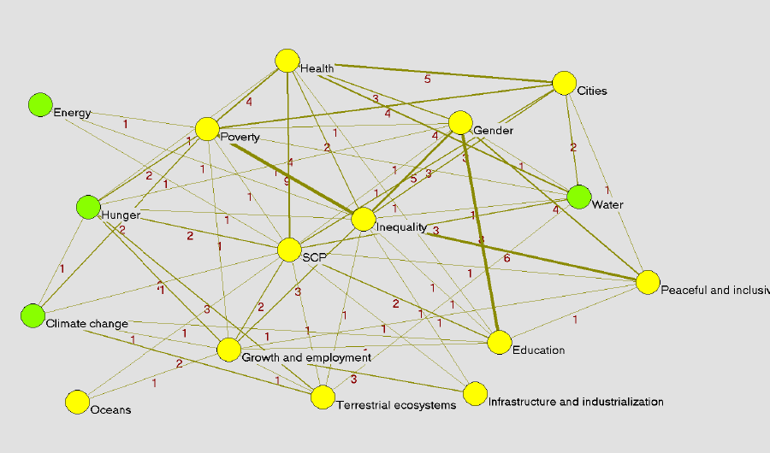
The network of targets provided by SDG 12 on Sustainable Consumption and Production. Note: the numbers on the map indicate the number of targets linking different goals. Source: UNDESA, 2015.
- The presence in the set of SDGs of targets that refer to multiple goals is aimed to facilitate integration and policy coherence across sectors. Such links among goals can facilitate real mainstreaming of dimensions that are at date not sufficiently anchored in other sector institutions, such as the environment. The fact that SCP play such an integrative role, builds an opportunity for the environmental sector to influence a broader agenda for sustainable development.

Delivering on the environmental dimension of the 2030 Agenda for Sustainable Development in LAC.

- Despite the paradigm shift agreed with the 2030 Agenda, there is still pending work in order to incorporate environmental considerations in the core of national development priorities. During the last decades, most economic development and growth strategies have encouraged rapid accumulation of physical, financial and human capital, at the expense of excessive depletion and degradation of natural capital, which includes the endowment of natural resources and ecosystems. The widespread disillusion with the prevailing economic paradigm, a sense of fatigue emanating from the different crises and market failures experiences in the last 10 years, has been key in the definition of a system of SDGs that strongly considers the environment. However, economic growth continues to be a chief priority for most governments, and the integration of environmental considerations into development planning is still lagging.
- Even though the economic and social benefits of sound environmental management are clearly identified, they are not used to ensure the required investment of human, institutional, financial and material resources. For example, the price we pay for market failures that lead to environmental and social externalities (i.e. environmental pollution and degradation) is high and growing. According to the World Health Organization, some 7 million people around the world die annually due exposure to indoor and outdoor air pollution. The situation is getting more critical with population growth, rapid urbanisation, climate change and industrialisation. Non-Communicable Diseases are increasingly the first cause of morbidity and mortality in LAC countries. Several countries in the region have calculated the costs related to the GDP of environmental degradation. As an example, the health costs associated to urban air pollution in Honduras are around USD 51 million per year and the ones associated to indoor pollution USD 59 million (Strukova, 2007 cited in Miambiente, 2014).
- The following points explore how the 2030 Agenda can be adapted and implemented at the national level and the different opportunities to integrate environmental considerations within the economic and social realms in the region in order to foster an integrated approach for sustainable development.

Multiple national approaches to Sustainable Development.
- The Rio+20 outcome recognized the existence of a number of “different approaches, visions, models and tools available to each country, in accordance with its national circumstances and priorities, to achieve sustainable development” (UN, The Future We Want, 2012). The Agenda 2030 builds on this concept recognizing that “targets are defined as aspirational and global, with each government setting its own national targets guided by the global level of ambition but taking into account national circumstances” (UNGA, 2015, parr. 55).
- LAC countries are as diverse in terms of their national priorities as they are in their approaches to development. The analysis of the visions of Argentina, Bolivia, Cuba, Ecuador, Nicaragua, and Venezuela (UNEP, 2013) and the recently issued “Multiple Pathways to Sustainable Development: Initial findings from the Global South” (UNEP, 2015c) show that each national sustainable development approach emphasize different things and have different conceptual underpinnings. However, the goals to which these approaches ultimately aspire are universal.
- A multiplicity of sustainable development approaches exists as countries develop their own responses to their unique challenges. Market-based approaches place human well-being and sustainability at the centre of the economy, challenging the way it is configured by using mechanisms to address policy, governance, and market failures. Ethics-based concepts, such as Living Well, define principles to guide our relationship with nature and firmly root it in our collective value system. Both approaches recognize that there are many cases where economics cannot capture the intrinsic value of nature or culture and, therefore, could be seen as complementary.
- In the LAC region, nearly all countries acknowledge the critical role of nature and ecosystems in their development plans and the subsequent need to preserve them. Another important common feature is the recognition of the essential role of the state to ensure government leadership for developing and enforcing the necessary regulatory frameworks and incentives to promote environmental protection, economic advancement and social equity. The one common element that unites all of these approaches is that “they all see sustainable development as much more than simply economic growth in the traditional sense, and they all place paramount importance on increased well-being, equitable (re)distribution of wealth, and the health of the environment” (UNEP, 2015c, p.56).

Decouple economic growth from environmental degradation.
- Making economic growth and development compatible with stabilizing the climate and reducing the ecological footprint will require a drastic shift towards clean development and green, low-carbon and resource-efficient economies worldwide. This requires a transformation of our current model but there is mounting evidence that suggests this will be a win-win situation with sound economic, environmental and social benefits, including: low-carbon climate-resilient development, resource and energy efficiency, social equity and protection, poverty alleviation, and decent and green job creation.
- In LAC, analysis undertaken by UNEP together with National Governments of Barbados, Colombia, Peru and Uruguay evidence that promoting environmental sustainable policies will have a positive effect on the economy and employment creation, while at the same time rationalize the use of natural resources to ensure long-term growth.
- Many LAC countries are already engaged in valuing ecosystem services or using economic instruments to spur environmental protection or promote sustainable use of natural resources. Caribbean countries, for example, have begun to take a more coordinated and strategic approach, exemplified by the agreement on developing a common regional vision on green economy and the national strategies being developed in Barbados, Jamaica and Saint Lucia.
- New approaches to planning, decision making and governance must be considered. For example, the use of economic instruments for environmental resource management is still limited and, in most cases, taking the form of isolated initiatives rather than as a component of a coordinated strategy. The inclusion of natural capital measures into national accounts can help mainstreaming ecosystem services into macro-economic policy. This can both inform sustainable development planning and ease the application of policy tools like ‘Payment for Ecosystem Services’. In Trinidad and Tobago, the Green Fund uses a 0.1% levy, applied to gross sales or receipts of business companies, to pay for ecosystem services such as shore protection and carbon sequestration by the values attributed to forest and coastal ecosystems (UNEP, 2015d).
- However the importance of indicators and metrics, the region recognizes that improvements on living conditions are tight with the engagement with nature itself. This is one of the main messages that LAC has promoted in the international arena, based on the knowledge and interaction of indigenous populations with nature.
- This relationship is based on a holistic and comprehensive vision that considers the relationship between the material, the emotional, and the spiritual spheres, promoting harmonious relationship of people with themselves, with their community, and with nature, enriching lifestyles that maintain the regenerative capacity of the planet. In fact, the 2030 Agenda reaffirms “that planet Earth and its ecosystems are our common home and that ‘Mother Earth’ is a common expression in a number of countries and regions” (UNGA, 2015, parr.59).

Moving to more sustainable consumption and production patterns: a cultural shift.
- Already in 2002, at the WSSD in Johannesburg, States recognised that “Fundamental changes in the way societies produce and consume are indispensable for achieving global sustainable development”. The 2030 Agenda reaffirms this by including sustainable patterns of consumption and production constitute one of the three overarching objectives of, and essential requirements for sustainable development. As the financial and environmental costs of resource depletion begin to affect economic growth worldwide, countries need to find ways to manage finite resources. On the other hand, as countries continue to improve their standard of living and develop their economies, consumption and disposal patterns change.
- In fact, changes in people’s living conditions, population growth, increased urbanization and increasing affluence have given rise to lifestyles that are increasingly contributing to environmental degradation, resource depletion and a growing waste generation. With under-developed infrastructure and inappropriate environmental management in urban areas, companies and public/private sector, the risk of negative and direct impacts on human and environmental health increases. The magnitude of this issue is not meaningfulness, as recent analysis on marine waste shows, warning that by 2050 there will be more plastics in the ocean than fish. For example, in the Caribbean region only tourism is estimated to generate as much of 166 million tons of waste per year.
- The double challenge of meeting the needs of growing urban areas with an expanding middle class is especially relevant in LAC where 80% of the population lives in urban zones and many countries have achieved middle income status. Integrated solutions are needed to modify the consumption and productions systems that allow meeting basic needs and human aspirations, increasing the well-being and promoting sustainable lifestyles.
- At the national and international markets there is already an incipient interest for green and sustainable products and services, and this tendency is expected to grow exponentially during the following years. Individual and corporate consumers increasingly choose socially, economically and environmentally preferable alternatives in order to fulfil their needs. However, this trend towards sustainable consumption and production is slower in LAC. There is an opportunity to support large and small and medium-sized enterprises of the region to adapt and seize to this growing opportunity by providing incentives and capacity development to implement SCP approaches such as: life cycle analysis, eco-innovation, sustainable value chains and extended producer responsibility, among many others.
- Governments can have a catalytic role in enabling a shift in consumer choices by integrating SCP priorities into national development planning and implementation. For example, the government, the private sector and the academia are jointly working in Brazil in order to develop sustainable criteria for the most commonly publicly purchased goods in the framework of the national sustainable procurement strategy.
- Therefore, policy makers can send a clear message to the private sector in the form of incentives and enabling conditions to produce goods and services more efficiently, with lower risks to health and the environment together with employment creation and the promotion of innovation. The adoption of the 10 Year Framework of Programmes on SCP (10YFP) and its implementation are highlighted in the SDGs, in particular in the target 12.1 as an important mechanisms to accelerate the shift to SCP and hence achieve several SDGs.

Ecosystem based resilience to decrease poverty and social inequalities.
- Poverty is often defined based on one measure: income. But poverty is multidimensional, and comprises other aspects related to exclusion and marginalization—such as inadequate living standards, lack of access to clean water, sustainable energy and productive resources, and poor health. Moreover, natural resources such as soils, forests, fisheries, water and minerals constitute a significant economic base in many countries. For example, the Caribbean SIDS crucially depend on biodiversity and ecosystem services that play a major role in supporting tourism and agriculture; in supplying drinking water; and in protecting against natural hazards and climate change adverse impacts. Particularly, natural resources are often the principal sources of income, social protection and employment for rural families and communities living in poverty. Therefore, environmental degradation and climate change are major obstacles to addressing poverty (UNDP-UNEP, 2015).
- At this regard, the LAC region is one of the most hazard-prone regions of the world and extremely vulnerable to climate change. Natural hazards have had a lethal and destructive impact in the region and millions of people have been directly affected as their housing, income-generating assets are damaged or destroyed. The region's pattern of development and, more specifically, the persistence of widespread poverty, rapid and uncontrolled urbanization and environmental degradation have led to an increase in its vulnerability. Only in the Caribbean, over a 25 year period, disasters claimed more than 240,000 lives and inflicted more than US$39 billion in damage (ECLAC, 2015b).
- Moreover, the poor and excluded suffer disproportionately from extreme weather and fluctuating climate patterns which can be deadly and/or destructive to peoples livelihoods and survival. Therefore, in order to improve countries and households resilience, it is important to buffer the harmful impacts of risks and shocks through comprehensive social protection schemes. The combination of social protection, sustainable land management and the use of modern financial instruments to target climate related risks will enable policy makers to adopt proactive policies that enable house-holds to leave poverty in an irreversible way.
- In the LAC region, social protection programmes, and particularly Conditional Cash Transfer (CCT) programmes, have probably been one of the most widely adopted anti-poverty initiatives. However, few of these programmes explicitly take environmental sustainability into consideration (e.g. Bolsa Verde in Brazil, Bona Mara in Chile, Bono de Desarrollo Humano in Ecuador and Communidade Solidario in Chile) (UNDP/UNEP, 2015). LAC countries could evolve to climate change-resilient social protection policy tools. For example, a pilot program on Dominican Republic (UNDP/UNEP Poverty and Environment Initiative), showed that the application of an Environmental Vulnerability Index can support the articulation of social protection policies with climate change adaptation and disaster risk management responses. This was done by adjusting the beneficiaries’ eligibility criteria including not only socio-economic but also environmental indicators.
- In a broader sense, the 2030 Agenda recognizes the role of nature-based solutions can play in food security, ‘green water storage’, flood risks mitigation and climate change adaptation for many of the most disadvantaged and marginalized sectors of society that have ecosystem-dependent livelihoods. In fact, the SDGs are directly linked to the health and biological diversity of ecosystems and the services they provide. For example, the ecosystem-based adaptation (EbA) approach provides sustainable, climate resilient, nature-based solutions that span many of the global challenges the SDGs seek to address, optimizing synergies and reducing trade-offs.
- Furthermore, from the 2030 Agenda lenses of ‘Leaving no one behind’, equal access to natural resources by the most disadvantage sectors of society is key for the fulfilment of their rights and to ensure equal development opportunities for all. The unequal distribution of the benefits arising from the use of using natural resources can exacerbate social marginalization; lack of timely access to environmental information, public participation in decision making and justice on environmental matters also create and exacerbate socio-environmental conflicts, affecting communities and persons in vulnerability situations. For example, ensuring equal access to land to women is a positive factor that improves food security and house-hold income and, therefore, indirectly increases access to education and health.

Challenges: fast looking forward

- From the analysis provided in the previous points, it could be concluded that sustainable development, while an appealing concept in theory, has not moved to the core of national development strategies. In fact, the analysis of the national reports prepared for Rio+20, states that “today's challenge is chiefly implementation” and that “a gap exists between stated commitments to sustainable development and the reality of implementing sustainable development policies and programmes” (UN DESA and UNDP, 2012).
- Several ingredients are critical to successful implementation: political will, good governance, relevant monitoring systems and inclusive dialogue processes that bring together diverse levels of government and stakeholders. At the core of this process is the need for each country to conduct national sustainable development implementation planning around the SDGs while laying the basis for systematic implementation monitoring and review.

Readiness phase will allow robust implementation: advances in LAC.
- Building public awareness and engaging national, sub-national and local stakeholders in The 2030 Agenda for Sustainable Development and SDGs is a critical initial and ongoing step in successful implementation. A clear understanding of the benefits of integrating this agenda into national and sub-national planning and policy-making processes provides the foundation for real and lasting transition to sustainable development.
- Countries in the LAC region are at different stages with respect to their awareness and integration of the 2030 Agenda and SDGs. They are also adopting different paths and schemes to align development priorities to this new framework. The next points illustrate different steps taken by some countries in this readiness phase:

Preliminary assessments to tailor SDGs to the national context.
- For example, Costa Rica conducted an initial review of the SDG targets and proposed indicators. Ecuador performed a similar process and assessed the national statistics institute to do a preliminary identification of gaps (it concluded that 130 of 169 targets are already reflected in the National Development Plan and that 35% of current indicators could be measured by existing statistics).

Integrating SDGs into national planning processes.
- Colombia, an original champion of the SDGs in Rio+20, is the first country to have the SDGs integrated in its National Development Plan. Jamaican Vision 2030 and Medium Term Socio-Economic Policy Framework (2015-2018) are also aligned with the 2030 Agenda. Belize has formulated a National Sustainable Development Strategy aligned with the new agenda.

Intersectoral coordination mechanisms and multi-stakeholder approaches.
- Panama created an Interinstitutional and Civil Society Commission to support and monitor the SDGs. Colombia has stablished a Technical Inter-sectoral Secretariat for SDGs lead by the National Department of Planning. Since the negotiations phase, Brazil works with an Interministerial Working Group involving the federal executive power and receives contributions from states, municipalities, civil society, social movements, private sector and the academia. Trinidad and Tobago has embarked in a National Dialogue on Mainstreaming the SDGs into National Development creating a multi-stakeholder platform.

Monitoring system and indicators.
- A list of indicators is being developed by the Inter-agency Expert Group (IAEG) on SDG Indicators aiming to measure progress towards the goals and targets. However, the region is already advancing in this topic. The Brazilian Institute for Statistics and Geography (IBGE) is supporting the work on the SDGs indicators, both at the national and regional level. Colombia has an innovative performance indicator dashboard in which more than 54% of the SDGs already have monitoring indicators. Honduras monitors intersectoral work through the Presidential Results-Based Management platform that leads to integrated SDG advancements. Mexico launched a data tool for sustainable development that already tracks 100 indicators related to the SDGs and the National Statistics Institute of Mexico has signed agreements with countries such as Honduras to stablish a Mesoamerican virtual platform for SDG advancement monitoring.
- The experience accumulated by the LAC Forum of Ministers of Environment in the definition of sustainable development indicators in the framework of the Latin America and the Caribbean Initiative on Sustainable Development (ILAC) is also an important element that can support the monitoring of the implementation of the 2030 Agenda and the SDGs.

Financing sustainable development.
- The Addis Ababa Action Agenda proposes a new financing framework and an array of mechanisms to effectively mobilize financial resources for the achievement of the SDGs. The SDG targets already consider an increasing mobilization of domestic and international resources with differentiated responsibilities for developing and developed countries. For example, it reiterates the importance of capitalizing the Green Climate Fund, for which several LAC national institutions are already in the process of being accredited.
- Additionally, the financial system will need to evolve to play its role in financing sustainable development. Brazil and Colombia are two countries in which there are innovative advances coming from central banks, financial regulators and standard-setters to incorporate sustainability factors into the rules that govern the financial system (UNEP, 2015b).

The role of Environment Ministries.
- Environment Ministries are being involved in different ways and degrees in these readiness steps. The main challenge for the environmental sector is to embrace a modern approach, applying its remit in a visionary way that breaks the mould of the traditional approaches. This implies ecosystem protection and minimization of environmental impacts of economic activities but also ensuring a more coherent mainstreaming of environmental considerations in regional and national priorities, plans and actions and demonstrating the multiple benefits of effectively applying an integrated approach.
- The SDGs offer unprecedented opportunities to engage with stakeholders across the spectrum of sustainable development and apply multi-sector approaches to reach the agreed targets. However, they also create, with its innovative approach, the challenge to advance on complex issues not sufficiently tackled before (trade and environment, long-term resilience of infrastructure, sustainability of cities, etc.).
- These require appropriate legislative and institutional frameworks, and the promotion of environmental rule of law. The LAC region has done some progress at this regard from and strengthening the structures capacities of environmental ministries to the creation of new institutions and inter-institutional mechanisms for policy coordination. New institutional arrangements have arisen in order to confront the challenges of planning for sustainable development and, more recently, to prepare countries to implement the SDGs. Additional to fostering intersectoral coherence, some countries have also advanced in the articulation and coordination with other development stakeholders such as the academia, the private sector and the civil society.
- Ministries of Environment are already having a very important role within interinstitutional mechanisms in charge of planning, implementing and monitoring sustainable development by:
      - Actively participate in political inter-sectoral coordination schemes both at national and decentralized levels.
      - Contribute to the achievement of the SDGs with specific plans of action and integrate the implementation of specific targets in their sector plans.
      - Partner with other key environmental and non-environmental actors at the national and local levels (civil society, communities, private sector) and global level (e.g. Multilateral Environmental Agreements´ constituencies).
      - Create enabling conditions for more sustainable production and consumption (sustainable public procurement, sustainable labels, R&D, among others).
      - Collect and providing information and analysis about the environment to ensure sound decision making in all development sectors and contribute to policy coherence. This includes a responsibility over the definition and monitoring of specific indicators.
- Regarding this last point, national environmental information systems will necessarily play a role in promoting a more effective and widespread use of environmental data and information in sustainable development policy and decision making. This has to do with three key aspects that should be strengthened in the region:
- Data availability and information gaps.-There are significant differences among LAC countries, in terms of data quality, quantity, and also thematic, spatial and temporal coverage. There are also significant data gaps, not only related to lack of data but also to its relevance to inform decisions related to sustainable development.
- Institutional capacities for access, integration and analysis to produce assessments informed by high quality and up to date data. Many countries have not implemented open data policies yet; additionally, even if such policies are in place, technical problems mostly related to interoperability and quality assurance, make it difficult to access, integrate and use in meaningful ways available data. In other cases, there is insufficient capacity to convert such data into relevant, easy-to-use information, such as integrated indicators or scenarios analysis.
- Communication and use in policy and decision making processes.- There are limitations for the effective uptake of the assessments by a wide range of stakeholders involved in policy and decision making at various levels. Advances should be made to fully exploit the available information to support national sustainable development policies, programmes and actions.

Regional cooperation for environmental sustainability.
- Sustainable development will be delivered at the country level based on each national conditions and realities. However, it does include many objectives, particularly related to the environment, which require a collective response of all countries and all peoples in the region. This reinforces the vision of the 2030 Agenda as a “partnership” for sustainable development.
- The region is definitively very actively involved in South-South and Triangular cooperation with all countries acting as recipients but also an increasing number also as providers. However, there is space to foster much more cooperation. In Latin America, the screening of 576 projects showed that South-South cooperation on environmental issues accounted for less than 5% of total initiatives (SEGIB, 2015). One successful example is the Caribbean Biological Corridor Initiative, an instrument of international cooperation between Cuba, Haiti and the Dominican Republic aimed to protect and reduce the loss of biodiversity, by rehabilitating the environment and alleviating poverty as a mean to reduce the pressure on biological resource.
- On the other hand, the LAC region has a remarkable number of regional and subregional forums and instruments addressing environment and sustainable development issues. Some organizational priorities and agendas are quite broad, covering a comprehensive set of environmental issues. They all serve to influence and coordinate regional positions, define well-defined issues to be jointly managed or for which a strengthened regional, South-South and technical cooperation is relevant. Due their strong alignment with the vision of the 2030 Agenda for Sustainable Development, special reference deserve the SIDS Accelerated Modalities of Action (SAMOA Pathway) and the recent revision of the Latin America and Caribbean Initiative for Sustainable Development (ILAC).
- In particular, the Forum of Ministers could play various roles in the implementation and follow up of the 2030 Agenda. Among others, it could:
- Be the space for peer-to-peer learning and lessons learnt sharing among member states.
- Facilitate regional collaboration and coordination, which acts as a platform to address environmental challenges which require a collective response (e.g. water management, climate change vulnerability, biodiversity conservation, fisheries, sustainable cities, among others).
- Ensure the definition of common positions and priorities on environmental issues in the follow-up and planned revisions of the 2030 Agenda.
- Determine “leverage points” of policy interventions with other Ministerial and regional intergovernmental fora through which changes in environmental sustainability can happen.
- Provide political messages and signals to the private sector and civil society in the region with the purpose of enabling for greater policy coherence across actors in the implementation of the SDGs.
- Additionally, the Latin America and Caribbean Initiative for Sustainable Development (ILAC) can serve as the tool to deliver the decisions adopted in the LAC Forum of Ministers as it provides the framework for strengthening south-south cooperation in the region. It can also help making operational the 2030 Agenda in the region by refining and localizing the SDGs, proposing a set of policy-relevant, multi-purpose environmental indicators specific for the region and carrying out actions for particular challenges faced. For example, strengthen and interconnect the national environmental information systems across the region, specifically in their capacity to support the continued production of assessments that are policy-relevant, up-to-date, dynamic and integrated.

Conclusions

- As the region begin to strengthen the paths towards sustainable development, countries face immense challenges ranging from fundamental assumptions about 1) economies and lifestyles, 2) limited public awareness about the implications of environmental degradation and increasing environmental vulnerability, to 3) heightened uncertainty about climate, natural productivity, human population and health, economic globalization, and security.
- Reversing the trend of increasing environmental degradation requires a change in lifestyle practices that reflects the reality of the region, rather than that of industrialized nations. The region must articulate national sustainable development visions based on equality while fostering sustainable consumption and production patterns.
- The likely repercussions for poor environmental planning or inaction will be severe and will risk the progress made so far. It also will avoid taking into account the opportunities and economic and social benefits that natural resources and ecosystems can provide.
- Therefore, the region must articulate a clear, long-term course and vision for sustainable development at the national and regional levels, looking beyond the immediate benefits and taking action that will lead to a sustainable future.
- The Agenda 2030 is an extraordinary opportunity to bring forward the mandate of protecting and sustainably use environment. The complete integration of environmental considerations in the SDGs implies fundamental changes in how the environmental sector is working with others. For example, environmental authorities should be present in decision making spaces with specific proposals that make the environmental message relevant to other pressing priorities such as national security, employment, and competitiveness. This will also require an institutional architecture aimed to plan and implement an integrated approach.
- Strong commitment, informed decisions and innovative and visionary action are required at every level of society in changing the development paradigm. In this sense, it is broadly recognize that governmental action will not be enough to ensure SDGs implementation. Therefore, new partnerships should be put in place building on the current enthusiasm of other development stakeholders that have been actively linked to the formulation of the 2030 Agenda, such as civil society, the academia and the private sector.
- Moreover, the potential of the region, based on its strong capacity and experience, builds an opportunity to strengthen South-South cooperation schemes involving not only governments but also civil society organizations, the academia and the private sector. This can be done not only in the framework of a regional agreement with the transformational vision of the 2030 Agenda but also on the solidarity that has traditionally characterized the region in the global context.
- The World only has 15 years ahead to accomplish the 2030 Agenda and the challenging transition to sustainable development that it encompasses. It is time for a renewed compromise for a sound implementation of the SDGs.

References

ECLAC, 2015a. Latin America and the Caribbean: looking ahead after the Millennium Development Goals. Santiago, Chile. Available from: http://www.cepal.org/
ECLAC, 2015b. The Caribbean and the post-2015 Agenda. Available from: http://www.cepal.org/
ESCAP, 2016. Integrating the three dimensions of sustainable development: a framework and tools. Available from: http://www.unescap.org/sites/default/files/Integrating%20the%20three%20dimensions%20of%20sustainable%20development%20A%20framework.pdf
General Assembly resolution 55/2, United Nations Millennium Declaration, A/RES/55/2 (18 September 2000). Available from: http://www.un.org/millennium/declaration/ares552e.pdf
General Assembly resolution 69/313, Addis Ababa Action Agenda of the Third International Conference on Financing for Development (Addis Ababa Action Agenda), A/RES/69/313 (27 July 2015). Available from: http://www.un.org/en/ga/search/view_doc.asp?symbol=A/RES/69/313
General Assembly resolution 70/01, Transforming our world: the 2030 Agenda for Sustainable Development, A/RES/70/01 (25 September 2015). Available from: http://www.un.org/ga/search/view_doc.asp?symbol=A/RES/70/1&Lang=E
IISD, 2015. Global Goals and the Environment: Progress and prospects. Available from: http://www.iisd.org/library/global-goals-and-environment-progress-and-prospects
Miambiente, 2014. Informe del Estado del Ambiente: GEO Honduras 2014. Tegucigalpa.
OECD, 2014. Better Policies for Development 2014: Policy Coherence and Illicit Financial Flows. OECD Publishing.
SEGIB, 2015. Report on South-South Cooperation in Latin America. Available from: https://issuu.com/segibpdf/docs/report-on-south-south-2015-ingles-n?e=18375375/14353148
UN Conference on Sustainable Development 216/L.1, The future we want, A/CONF./216/L.1 (19 June 2012). Available from: https://sustainabledevelopment.un.org/futurewewant.html
UN DESA, 2015. Towards integration at last? The sustainable development goals as a network of targets. Available from: http://www.un.org/esa/desa/papers/2015/wp141_2015.pdf
UNDG, 2015. Guidance Note on supporting the tailoring of the 2030 Agenda for Sustainable Development to National Contexts. Available from: https://undg.org/main/undg_document/undg-maps-strategy/
UNDP-UNEP, 2015. Mainstreaming Environment and Climate for Poverty Reduction and Sustainable Development. A Handbook to Strengthen Planning and Budgeting Processes. UNDP-UNEP Poverty-Environment Initiative. Available from: http://www.undp.org/content/undp/en/home/librarypage/poverty-reduction/mainstreaming-environment-and-climate-for-poverty-reduction-and-.html
UNEP, 2009. TEEB for policy makers – Summary: responding to the Value of Nature. Available from: http://www.teebweb.org/publication/teeb-for-policy-makers-summary-responding-to-the-value-of-nature/
UNEP, 2011. Towards a Green Economy: Pathways to Sustainable Development and Poverty Eradication. Available from: http://www.unep.org/greeneconomy/Portals/88/documents/ger/ger_final_dec_2011/Green%20EconomyReport_Final_Dec2011.pdf
UNEP, 2013. Development strategies of selected Latina American and Caribbean countries and the green economy approach: A comparative analysis. Available from: http://www.greengrowthknowledge.org/resource/development-strategies-selected-latin-american-and-caribbean-countries-and-green-economy
UNEP, 2015a. Environmental Sustainability for Human Well-being in the Post-2015 Development Agenda. Available from: http://www.unep.org/post2015/Portals/50240/Documents/UNEA_INF18_SDG-fa.pdf
UNEP, 2015b. The financial system we need: aligning the financial system with sustainable development. Available from: http://web.unep.org/inquiry/publications
UNEP, 2015c. Multiple paths to sustainable development: Initial findings from the global south. Available from: http://gdprte.ueb.edu.vn/en-article-Multiple-Pathways-to-Sustainable-Development--Initial-Findings-from-the-Global-South-13842-1227.html
UNEP, 2015d. Success Stories in Mainstreaming Ecosystem Services into Macro-economic Policy and Land Use Planning: Evidence from Chile, Trinidad and Tobago, South Africa and Viet Nam. Available from: http://reliefweb.int/sites/reliefweb.int/files/resources/Global%20synthesis%20report.pdf
UNEP, 2015e. Sustainable Consumption and production indicators for the future SDGs. Available from: http://www.iisd.org/library/sustainable-consumption-and-production-indicators-future-sdgs
UNEP, 2015f. Uncovering pathways towards and inclusive green economy: a summary for leaders. Available from: http://www.unep.org/greeneconomy/Portals/88/documents/GEI%20Highlights/IGE_NARRATIVE_SUMMARY.pdf

Targets in all the SDGs that have a letter in their numeration and SDG 17.
The complete studies can be found in http://www.unep.org/greeneconomy/
The Haitian earthquake in 2010 accounted for 222,570 lives lost and US$8 billion in damage.
Defined as “the sustainable management, protection, restoration or transformation, of biodiversity and ecosystem services as part of an overall adaptation strategy to help people adapt to climate change”.
https://www.gacetaoficial.gob.pa/pdfTemp/27870_B/GacetaNo_27870b_20150917.pdf
http://unstats.un.org/sdgs/iaeg-sdgs/
Brazil is Mercosur’s + Chile representative at the United Nations’ Inter-Agency and Expert Group on SDGs Indicators.
https://sinergia.dnp.gov.co
http://datos.gob.mx/
According to a recent questionnaire done by UNEP Regional Office for LAC.
http://www.cbcpnuma.org/
Some mechanisms focus on the political level, such as: the Community of Latin American and Caribbean States (CELAC), the Bolivarian Alliance for the Peoples of Our America (ALBA) and the Organization of American States (OAS). Others combine this with a defined agenda, strategy, monitoring mechanism at the operational level, as well as a secretariat, such as such as: the Amazon Cooperation Treaty Organization, the Andean Community, the Caribbean Community (CARICOM), the Organisation of Eastern Caribbean States (OECS), and the Central American Commission for Environment and Development (CCAD) of the Central American Integration System (SICA). Others are thematic instruments, including the Regional Seas Programme for the Caribbean and a large number of river basin agreements and mechanisms.

